Documento de Experimento

Peticiones a medir:

paciente/:id/episodios

|  |  |  |  |  |  |  |  |  |
| --- | --- | --- | --- | --- | --- | --- | --- | --- |
| Etiqueta | # MUESTRA | PROMEDIO | MIN | MAX | DESV | ERROR% | RENDIMIENTO /S | Rendimiento KB/S |
| Petición HTTP | 13000 | 50 | 9 | 358 | 30,78% | 0.0 | 218,62 | 1492,787532 |

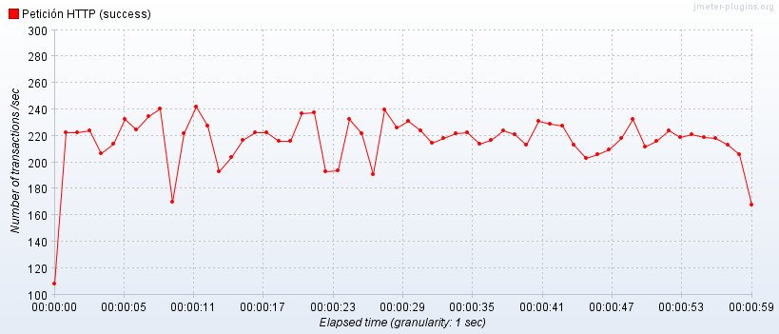

paciente/:id/episodio/:id

|  |  |  |  |  |  |  |  |  |
| --- | --- | --- | --- | --- | --- | --- | --- | --- |
| Etiqueta | # MUESTRA | PROMEDIO | MIN | MAX | DESV | ERROR% | RENDIMIENTO /S | Rendimiento KB/S |
| Petición HTTP | 13000 | 53 | 9 | 330 | 31,27% | 0.0 | 214,23 | 1462,824031 |

